Article Title
Author, Affiliation
ORCID ID: XXXX-XXXX-XXXX-XXXX
Abstract: Latin text for the sample. Lorem ipsum dolor sit amet, consectetuer adipiscing elit. Maecenas porttitor congue massa. Fusce posuere, magna sed pulvinar ultricies, purus lectus malesuada libero, sit amet commodo magna eros quis urna. Nunc viverra imperdiet enim. Fusce est. Vivamus a tellus. Pellentesque habitant morbi tristique senectus et netus et malesuada fames ac turpis egestas. Proin pharetra nonummy pede. Mauris et orci.
Keywords: Insert 3 to 5 keywords, comma separated
See Documents | Accessibility Resources at UNCG for additional tips on accessibility.

Introduction
Insert meaningful link text such as North Carolina Libraries rather than generic terms such as “link” or “learn more.”
General requirements:
- Use only black text for all body content.
- If you need to emphasize text, use bold or italics rather than any other colored font.
- Do not use tabs or spaces to align text.
- Use paragraph spacing settings (Format>Paragraph) to add space between paragraphs rather than pressing Enter multiple times.
- Do not use page breaks or format the text into columns.
- Write out acronyms the first time you use them.
- Insert special characters using Insert>Symbol rather than copying from another source.
Finally, submit your manuscript in .dox format with Track Changes turned off and all changes accepted.

Section One
Sample Latin text to replace with your own. Lorem ipsum dolor sit amet, consectetuer adipiscing elit. Maecenas porttitor congue massa. Fusce posuere, magna sed pulvinar ultricies, purus lectus malesuada libero, sit amet commodo magna eros quis urna. Nunc viverra imperdiet enim. Fusce est. Vivamus a tellus. Pellentesque habitant morbi tristique senectus et netus et malesuada fames ac turpis egestas. Proin pharetra nonummy pede. Mauris et orci.
Aenean nec lorem. In porttitor. Donec laoreet nonummy augue. Suspendisse dui purus, scelerisque at, vulputate vitae, pretium mattis, nunc. Mauris eget neque at sem venenatis eleifend. Ut nonummy. Fusce aliquet pede non pede. Suspendisse dapibus lorem pellentesque magna. Integer nulla.

Subsection 1.1
Sample Latin text to replace with your own. Donec blandit feugiat ligula. Donec hendrerit, felis et imperdiet euismod, purus ipsum pretium metus, in lacinia nulla nisl eget sapien. Donec ut est in lectus consequat consequat. Etiam eget dui. Aliquam erat volutpat. Sed at lorem in nunc porta tristique. Proin nec augue. Quisque aliquam tempor magna. Pellentesque habitant morbi tristique senectus et netus et malesuada fames ac turpis egestas.
Ordered Lists: Use Word’s built-in ordered list options, numeric or alphabetical:
- Item one
- Item two
  - Sub-item two.one
  - Sub-item two.two
Continue with subsection 1.1 text at the end of the ordered list. For unordered lists, use Word’s built-in options for bulleted lists.

Subsection 1.2
Sample Latin text to replace with your own. Nunc ac magna. Maecenas odio dolor, vulputate vel, auctor ac, accumsan id, felis. Pellentesque cursus sagittis felis. Pellentesque porttitor, velit lacinia egestas auctor, diam eros tempus arcu, nec vulputate augue magna vel risus. Cras non magna vel ante adipiscing rhoncus. Vivamus a mi. Morbi neque. Aliquam erat volutpat. Integer ultrices lobortis eros.
Tables: Insert a table rather than only using spaces or tabbing.
Table 1 Right-click table and select “Insert Caption” to describe purpose and interpretation of table.
Column Header 1 | Column Header 2 | Column Header 3 | Column Header 4
Name ABC | Data 1-ABC | Data 2-ABC | Data 3-ABC
Name DEF | Data 1-DEF | Data 2-DEF | Data 3-DEF
Name GHI | Data 1-GHI | Data 2-GHI | Data 3-GHI

Section Two: Images
Indicate where your images should go in logical reading order by adding <Insert Image 1> at the desired location, and add the caption. Be sure to add alt text. If the image is purely decorative, mark as decorative in the alt-text menu. Submit JPEG or TIFF images as separate files. If your image is intended to be a small inline image, it should be 600 pixels on the long axis; half page images should be 800 pixels; and full page images need to be 1200 pixels. The file name for each should be a short title and image number, for instance Sample_Article_Image_1 and Sample_Article_Image_2. For more information, see Clemson’s “Images in Word” webpage.
<Insert Image 1>Image 1: Notebooks with Fabric Covers
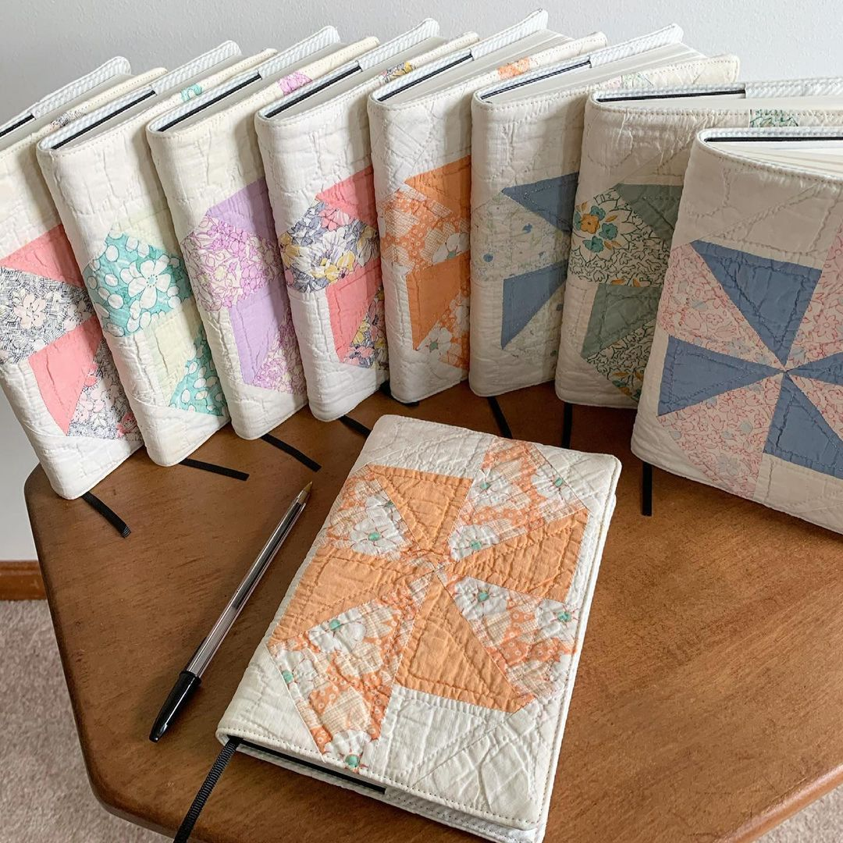
Charts, graphs, and maps can present difficulties for screen readers and colorblind users. If it is crucial to the content of your article, provide a text description of the image, and supplement color-coding of charts with texture, differences in line style, text in graphs, or different shades of color to improvide accessibility. See Accessibility at Penn State | Charts & Accessibility.
<Insert Image 2>Image 2: Sample Accessible Line Chart
This chart uses differences in line style to help distinguish elements, and labels each one.
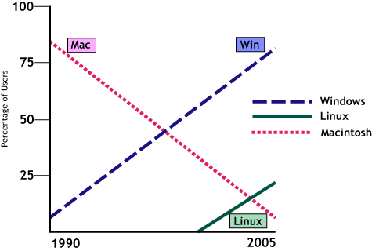

References
The following references are from Purdu’s Online Writing Lab (OWL) APA Sample Paper. Please hyperlink the title and remove the hyperlink from the DOI or URL at the end of the reference, in keeping with “Using descriptive links in APA Style.”
Ambady, N., & Rosenthal, R. (1993). Half a minute: Predicting teacher evaluations from thin slices of nonverbal behavior and physical attractiveness. Journal of Personality and Social Psychology, 64(3), 431–441. http://dx.doi.org/10.1037/0022-3514.64.3.431
American Association of University Professors. (n.d.). Background facts on contingent faculty positions. https://www.aaup.org/issues/contingency/background-facts
American Association of University Professors. (2018, October 11). Data snapshot: Contingent faculty in US higher ed. AAUP Updates. https://www.aaup.org/news/data-snapshotcontingent-faculty-us-higher-ed#.Xfpdmy2ZNR4
Anderson, K., & Miller, E. D. (1997). Gender and student evaluations of teaching. PS: Political Science and Politics, 30(2), 216–219. https://doi.org/10.2307/420499
Armstrong, J. S. (1998). Are student ratings of instruction useful? American Psychologist, 53(11), 1223–1224. http://dx.doi.org/10.1037/0003-066X.53.11.1223
Attiyeh, R., & Lumsden, K. G. (1972). Some modern myths in teaching economics: The U.K. experience. American Economic Review, 62(1), 429–443. https://www.jstor.org/stable/1821578
Bachen, C. M., McLoughlin, M. M., & Garcia, S. S. (1999). Assessing the role of gender in college students' evaluations of faculty. Communication Education, 48(3), 193–210. http://doi.org/cqcgsr
Basow, S. A. (1995). Student evaluations of college professors: When gender matters. Journal of Educational Psychology, 87(4), 656–665. http://dx.doi.org/10.1037/0022-0663.87.4.656
Becker, W. (2000). Teaching economics in the 21st century. Journal of Economic Perspectives, 14(1), 109–120. http://dx.doi.org/10.1257/jep.14.1.109
Benton, S., & Young, S. (2018). Best practices in the evaluation of teaching. Idea paper, 69.
Berk, R. A. (2005). Survey of 12 strategies to measure teaching effectiveness. International Journal of Teaching and Learning in Higher Education, 17(1), 48–62.
Bloom, B. S., Englehart, M. D., Furst, E. J., Hill, W. H., & Krathwohl, D. R. (1956). Taxonomy of educational objectives: The classification of educational goals. Addison-Wesley Longman Ltd.
Carrell, S., & West, J. (2010). Does professor quality matter? Evidence from random assignment of students to professors. Journal of Political Economy, 118(3), 409–432. https://doi.org/10.1086/653808
Cashin, W. E. (1990). Students do rate different academic fields differently. In M. Theall & J. L. Franklin (Eds.), Student ratings of instruction: Issues for improving practice (pp. 113– 121).
Centra, J., & Gaubatz, N. (2000). Is there gender bias in student evaluations of teaching? The Journal of Higher Education, 71(1), 17–33. https://doi.org/10.1080/00221546.2000.11780814
Davis, B. G. (2009). Tools for teaching (2nd ed.). Jossey-Bass. Denton, D. (2013). Responding to edTPA: Transforming practice or applying shortcuts? AILACTE Journal, 10(1), 19–36.

